Distributed Systems

What is a Distributed Systems?
# Source: Chatgpt (GPT-5-Mini) at [1/16/2026]
Distributed systems are computer systems made up of multiple independent computers (nodes) that work together and appear to users as a single coherent system.
These computers are connected through a network and coordinate their actions by passing messages to achieve a common goal.

Simple Definition
# Source: Chatgpt (GPT-5-Mini) at [1/16/2026]
A distributed system is a collection of computers that:
- Communicate over a network
- Share resources or tasks
- Coordinate to act like one system

Key Characteristics
# Source: Chatgpt (GPT-5-Mini) at [1/16/2026]
- Multiple nodes
Several computers run at the same time, often in different locations.
- No shared memory
Nodes communicate by sending messages, not by sharing RAM.
- Concurrency
Many operations happen simultaneously.
- Fault tolerance
The system continues working even if some nodes fail.
- Scalability
New nodes can be added to handle more load.
- Transparency
Users don’t need to know where data or computation is happening.

Types of distributed systems
# Source: Chatgpt (GPT-5-Mini) at [1/16/2026]
Distributed systems can be categorized based on their architecture, communication style, and purpose. Here’s a clear breakdown:

1. Based on Architecture
a) Client-Server Systems
- Description: One or more servers provide resources/services, clients request them.
- Example: Web servers, email servers.
- Features:
  - Centralized control
  - Clients depend on servers

b) Peer-to-Peer (P2P) Systems
- Description: All nodes (peers) are equal; each can act as client and server.
- Example: BitTorrent, blockchain networks.
- Features:
  - Decentralized
  - Fault-tolerant
  - Scales well

c) Multi-tier (N-tier) Systems
- Description: Systems are split into layers (tiers), e.g., presentation, application, database.
- Example: Online shopping websites.
- Features:
  - Modular design
  - Each tier can be scaled independently

d) Cluster Systems
- Description: A group of computers work together as a single system for high performance.
- Example: High-performance computing (HPC) clusters.
- Features:
  - Tight coupling
  - Shared workload

e) Grid Systems
- Description: Distributed resources across multiple locations connected via network; used for large-scale computation.
- Example: SETI@home, scientific research grids.
- Features:
  - Loosely coupled
  - Heterogeneous resources

f) Cloud Computing Systems
- Description: Resources (storage, computation) are delivered as services over the Internet.
- Example: AWS, Google Cloud, Azure.
- Features:
  - On-demand scalability
  - Pay-as-you-go model

2. Based on Communication/Coordination
a) Message-Passing Systems
- Nodes communicate by sending messages over the network.
- Example: MPI (Message Passing Interface) in supercomputers.
b) Shared Memory Systems
- Multiple nodes access a common logical memory (often virtualized over a network).
- Example: Distributed shared memory systems in multi-core processors.

3. Based on Purpose / Function
a) Distributed Databases
- Stores data across multiple nodes for redundancy and scalability.
- Example: Google Spanner, Cassandra, MongoDB.
b) Distributed File Systems
- Provides access to files across multiple machines as if they were local.
- Example: HDFS (Hadoop Distributed File System), NFS.
c) Real-Time Distributed Systems
- Guarantees responses within strict time limits.
- Example: Air traffic control systems, industrial control systems.
d) Fault-Tolerant Systems
- Designed to continue functioning even if some components fail.
- Example: Banking transaction systems.

✅ Summary Table:
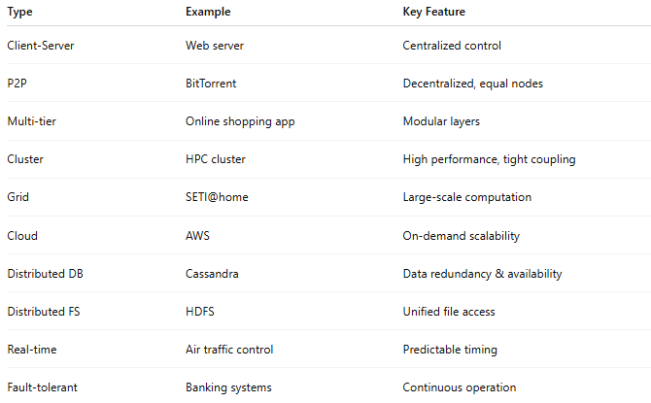
Type | Example | Key Feature
Client-Server | Web server | Centralized control
P2P | BitTorrent | Decentralized, equal nodes
Multi-tier | Online shopping app | Modular layers
Cluster | HPC cluster | High performance, tight coupling
Grid | SETI@home | Large-scale computation
Cloud | AWS | On-demand scalability
Distributed DB | Cassandra | Data redundancy & availability
Distributed FS | HDFS | Unified file access
Real-time | Air traffic control | Predictable timing
Fault-tolerant | Banking systems | Continuous operation

Distributed systems with diagrams
# Source: Chatgpt (GPT-5-Mini) at [1/16/2026]
Let’s make distributed systems easy to visualize. I’ll explain key types with diagrams so it’s clear how nodes communicate and work together.

1. Client-Server Distributed System
Concept:
Clients request services; servers provide resources. Centralized control.
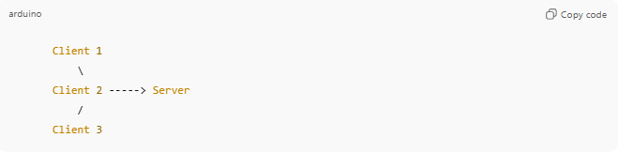
Client 1
\
Client 2 -----> Server
/
Client 3
Explanation:
- Clients send requests to the server.
- Server processes requests and sends responses.
- Single server can become a bottleneck if too many clients.
Example: Web servers, Email servers.

2. Peer-to-Peer (P2P) System
Concept:
All nodes are equal; each can act as client and server.
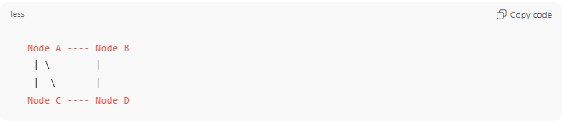
Node A ---- Node B
| \ |
| \ |
Node C ---- Node D
Explanation:
- Each node shares resources and communicates directly.
- No central server.
- Highly fault-tolerant.
Example: BitTorrent, Blockchain networks.

3. Multi-tier (N-tier) System
Concept:
System split into layers: presentation, application, database.
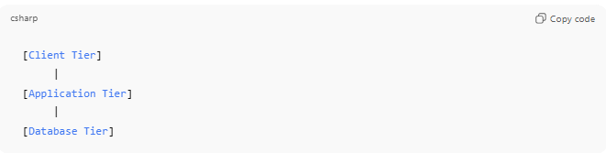
[Client Tier]
|
[Application Tier]
|
[Database Tier]
Explanation:
- Clients interact with the application layer.
- Application processes logic and communicates with database layer.
- Each layer can be scaled independently.
Example: E-commerce websites (Amazon, eBay).

4. Cluster System
Concept:
Group of tightly-coupled computers acting as a single system for high performance.
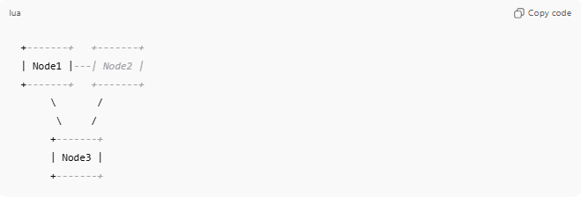
+-------+ +-------+
| Node1 |---| Node2 |
+-------+ +-------+
\ /
\ /
+-------+
| Node3 |
+-------+
Explanation:
- Nodes work together on the same task.
- Typically used for parallel computing.
Example: High-performance computing clusters (HPC).

5. Grid System
Concept:
Loosely-coupled, distributed resources across locations for large-scale computation.
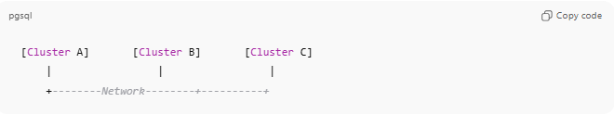
[Cluster A] [Cluster B] [Cluster C]
| | |
+--------Network--------+----------+
Explanation:
- Each cluster may have different hardware.
- Useful for massive computations (scientific research).
Example: SETI@home, CERN computing grid.

6. Cloud Computing System
Concept:
Resources (compute, storage) delivered as services over the Internet.
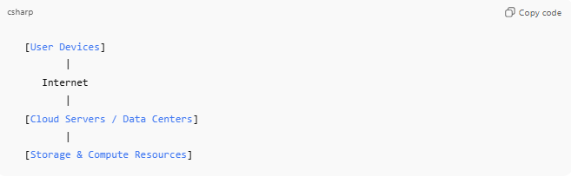
[User Devices]
|
Internet
|
[Cloud Servers / Data Centers]
|
[Storage & Compute Resources]
Explanation:
- Scalable, on-demand resources.
- Distributed across data centers globally.
Example: AWS, Google Cloud, Microsoft Azure.

7. Distributed Database / File System
Concept:
Data is stored across multiple servers for redundancy and scalability.
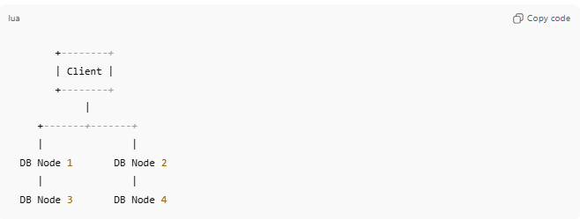
+--------+
| Client |
+--------+
|
+-------+-------+
| |
DB Node 1 DB Node 2
| |
DB Node 3 DB Node 4
Explanation:
- Data replicated across nodes.
- Client can read/write to any node.
- Ensures fault tolerance.
Example: Cassandra, HDFS, Google Spanner.

✅ Summary Diagram: Distributed Systems Types
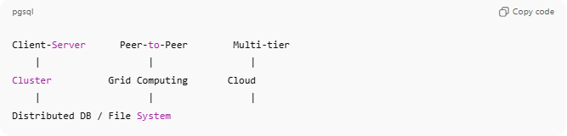
Client-Server Peer-to-Peer Multi-tier
| | |
Cluster Grid Computing Cloud
| | |
Distributed DB / File System

Examples of Distributed Systems
# Source: Chatgpt (GPT-5-Mini) at [1/16/2026]
- The Internet
- Cloud computing platforms (AWS, Azure, Google Cloud)
- Distributed databases (Cassandra, MongoDB, Google Spanner)
- Microservices architectures
- Peer-to-peer networks (BitTorrent)
- Blockchain systems (Bitcoin, Ethereum)

Why Use Distributed Systems?
# Source: Chatgpt (GPT-5-Mini) at [1/16/2026]
- Better performance (parallel processing)
- High availability (no single point of failure)
- Scales easily for large workloads
- Resource sharing across locations

Common Challenges
# Source: Chatgpt (GPT-5-Mini) at [1/16/2026]
- Network failures & latency
- Data consistency
- Synchronization
- Security
- Complex debugging

Real-World Analogy
# Source: Chatgpt (GPT-5-Mini) at [1/16/2026]
Think of a team of people working remotely:
- Each person works independently
- They communicate via messages (emails, chats)
- Together, they complete one project
That’s how a distributed system works.

Real-world use cases
# Source: Chatgpt (GPT-5-Mini) at [1/16/2026]
Distributed systems are everywhere in real life. Here’s a detailed list of real-world use cases grouped by type and functionality:

1. Cloud Computing & Storage
- Use Case: Storing and processing large amounts of data in the cloud.
- Examples:
  - Google Drive / Dropbox – Users access files stored across multiple servers.
  - AWS / Azure / Google Cloud – On-demand computing resources for businesses.
- Why Distributed: Data is replicated across servers for availability, fault tolerance, and scalability.

2. Online Banking & Financial Systems
- Use Case: Managing transactions, ATMs, and online banking securely.
- Examples:
  - Banking networks (SWIFT, Visa, MasterCard) – Multiple nodes process transactions worldwide.
  - Stock exchanges – Orders are processed across distributed servers in real time.
- Why Distributed: Ensures high availability, fault tolerance, and fast transaction processing.

3. E-commerce Platforms
- Use Case: Handling millions of users, product catalogs, orders, and payments simultaneously.
- Examples:
  - Amazon, eBay, Shopify – Frontend servers, app servers, and databases are distributed.
- Why Distributed: Allows scaling for high traffic, data replication, and redundancy.

4. Social Media Platforms
- Use Case: Delivering real-time updates, messages, and notifications globally.
- Examples:
  - Facebook, Instagram, Twitter (X) – Posts, likes, and messages are processed on distributed servers worldwide.
- Why Distributed: Supports millions of concurrent users and reduces latency.

5. Streaming Services
- Use Case: Streaming videos or music to millions of users simultaneously.
- Examples:
  - Netflix, YouTube, Spotify – Video/audio data stored in multiple distributed servers (CDNs).
- Why Distributed: Improves performance, reduces buffering, and ensures availability.

6. Scientific & Research Computation
- Use Case: Performing large-scale computations that single machines cannot handle.
- Examples:
  - SETI@home, CERN experiments – Data analysis across grids of computers.
- Why Distributed: Enables parallel processing and shared computing resources.

7. Online Gaming
- Use Case: Multiplayer games require synchronized updates for all players in real time.
- Examples:
  - Fortnite, PUBG, Call of Duty – Game servers are distributed globally.
- Why Distributed: Ensures low latency, fault tolerance, and real-time synchronization.

8. Blockchain & Cryptocurrencies
- Use Case: Secure, decentralized transactions without a central authority.
- Examples:
  - Bitcoin, Ethereum – Each node maintains a copy of the ledger.
- Why Distributed: Provides decentralization, transparency, and fault tolerance.

9. Distributed Databases
- Use Case: Managing huge amounts of structured/unstructured data reliably.
- Examples:
  - Cassandra, MongoDB, Google Spanner – Data replicated across nodes.
- Why Distributed: Enables scalability, high availability, and redundancy.

10. Content Delivery Networks (CDNs)
- Use Case: Delivering static and dynamic web content quickly to users worldwide.
- Examples:
  - Cloudflare, Akamai, Fastly – Copies of content stored in servers across the globe.
- Why Distributed: Reduces latency and load on origin servers.

✅ In Short:
Distributed systems power almost every service that is global, scalable, or highly available—from banking and gaming to social media and cloud computing.

CAP theorem
# Source: Chatgpt (GPT-5-Mini) at [1/16/2026]
The CAP theorem is a fundamental concept in distributed systems that describes the trade-offs between three key properties a distributed system can provide.
It was introduced by Eric Brewer in 2000.

1. What CAP Stands For
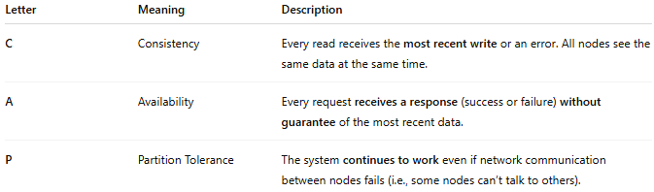
Letter | Meaning | Description
C | Consistency | Every read receives the most recent write or an error. All nodes see the same data at the same time.
A | Availability | Every request receives a response (success or failure) without guarantee of the most recent data.
P | Partition Tolerance | The system continues to work even if network communication between nodes fails (i.e., some nodes can’t talk to others).

2. The Core Idea
- In a distributed system, you can only fully guarantee two out of the three properties at the same time.
- You cannot have all three simultaneously in the presence of network partitions.
Think of it as a triangle—choosing two properties sacrifices the third:
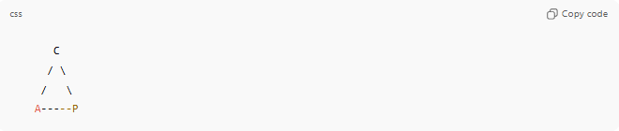
C
/ \
/ \
A-----P

3. Possible Combinations
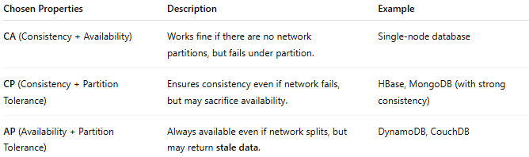
Chosen Properties | Description | Example
CA (Consistency + Availability) | Works fine if there are no network partitions, but fails under partition. | Single-node database
CP (Consistency + Partition Tolerance) | Ensures consistency even if network fails, but may sacrifice availability. | HBase, MongoDB (with strong consistency)
AP (Availability + Partition Tolerance) | Always available even if network splits, but may return stale data. | DynamoDB, CouchDB

4. Real-Life Analogy
Imagine two banks in different cities sharing account data:
- Consistency (C): Both banks always show the same balance.
- Availability (A): You can always withdraw money from any branch.
- Partition Tolerance (P): Even if the network between cities is down, the system still operates.
⚠️ You can’t have all three:
- If the network is down, either you risk inconsistency (AP) or some branches are unavailable (CP).

5. Why It Matters
CAP theorem helps architects choose the right trade-offs when designing distributed systems:
- If you need strict accuracy, prioritize C + P.
- If you need always-on service, prioritize A + P.
- If the network is reliable and simple, C + A may be enough.

Relation between Server Models and distributed systems
# Source: Chatgpt (GPT-5-Mini) at [1/16/2026]
Relation Between Server Models and Distributed Systems
Server models define how clients and servers interact in a system, while distributed systems describe how multiple independent computers work together to perform tasks. Understanding the relation helps design efficient, scalable, and fault-tolerant distributed applications.

Key Points of Relation
- Server Models Are Implementations in Distributed Systems
  - Distributed systems often use server models (Client-Server, Two-Tier, Three-Tier, Multi-Tier, or P2P) to organize how nodes communicate and provide services.
  - Example: A three-tier web application is a distributed system with client, application server, and database server across different machines.
- Tiered Server Models Enhance Distributed System Properties
  - Two-tier and three-tier models separate concerns:
    - Client: User interface
    - Application server: Business logic
    - Database server: Data storage
  - This modularity improves scalability, fault tolerance, and maintainability in distributed systems.
- P2P Model Shows Fully Decentralized Distributed Systems
  - In a Peer-to-Peer (P2P) server model, each node acts as both client and server.
  - This represents fully decentralized distributed systems where no central server exists.
- Server Models Determine Communication Patterns
  - Message Passing: Used in client-server and multi-tier models for request/response between nodes
  - Shared Data Access: Some distributed databases may resemble multi-tier server models with central coordination
- Performance and Fault-Tolerance
  - Multi-tier and distributed server models help distribute load across multiple nodes, improving performance and fault tolerance.
  - HA clusters and load-balancing clusters often implement multi-tier or replicated server architectures.

Example Mapping
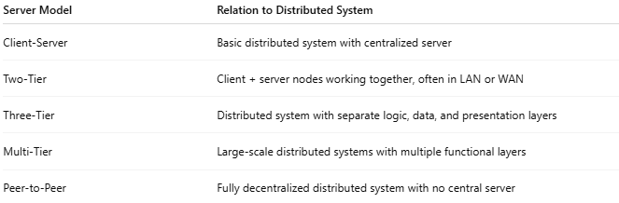
Server Model | Relation to Distributed System
Client-Server | Basic distributed system with centralized server
Two-Tier | Client + server nodes working together, often in LAN or WAN
Three-Tier | Distributed system with separate logic, data, and presentation layers
Multi-Tier | Large-scale distributed systems with multiple functional layers
Peer-to-Peer | Fully decentralized distributed system with no central server

Simple Analogy
- Distributed system: Multiple workers across a factory (or multiple factories) completing a big project
- Server model: How work is organized—who reports to whom, who handles which task, and how tasks are coordinated

✅ In short:
Server models define the architecture and interaction pattern of nodes in a distributed system. The choice of server model affects scalability, fault tolerance, performance, and complexity of the distributed system.

Diagram showing all server models mapped onto distributed systems
# Source: Chatgpt (GPT-5-Mini) at [1/16/2026]
